Service Types

What are Service Types?

ClusterIP services are needed because Pods are ephemeral and since they are destroyed frequently, we need to set a service that has a persistent IP address.

ClusterIP is a default service to enable network connectivity. Imagine you have a pod running an application on port 3000 and a logging application running on port 9000.

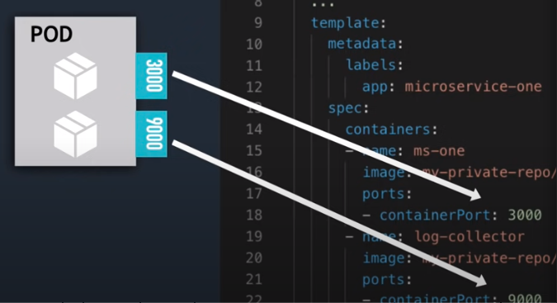
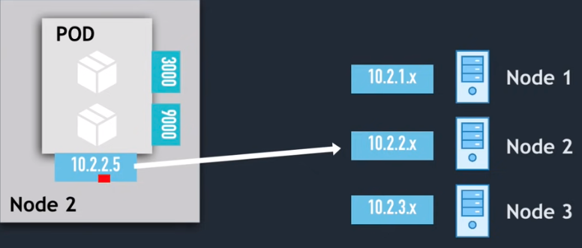
These two ports will now be open and accessible inside the pod. The pod will also get an IP from a CIDR range assigned to the node. Each node will get a range of different IP addresses.

In order to see your pod IP’s we can execute the kubectl get pod -o wide command. By identifying the subnets, we can also see which node is assigned to the pods. The ClusterIP services would then give these nodes the ability to reach the internet through something called an ingress, which we will discuss later.
For now, just understand that a ClusterIP service type is an internal service that is the default type needed to enable network connectivity and is only accessible within the cluster.

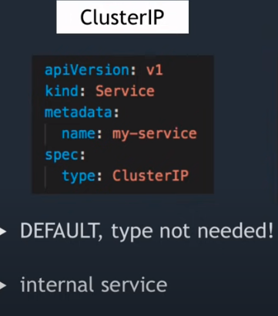
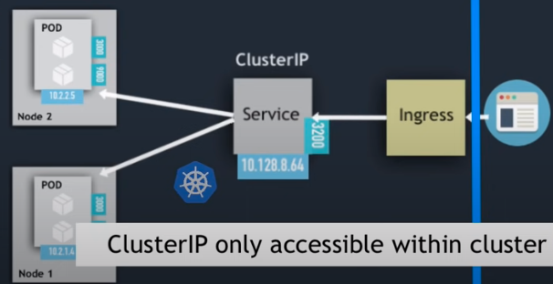

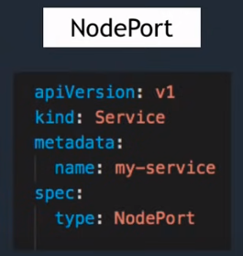
NodePort is a service type that creates a static port that's accessible on each worker node in the cluster.

NodePort allows external traffic to come directly to the worker node on the specified port. This differs from ClusterIP as NodePort doesn't require an ingress resource to connect to the internet.

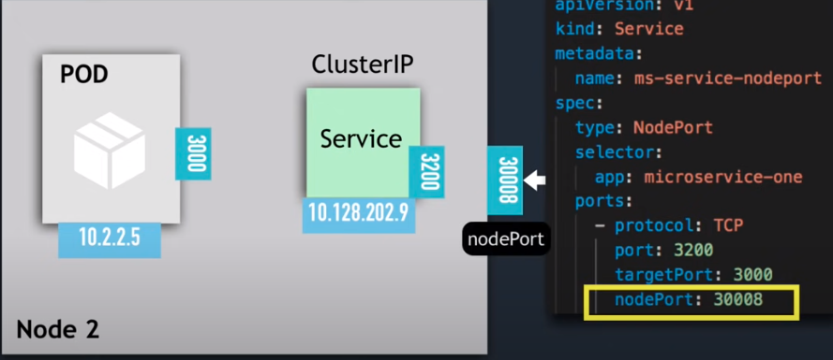
The NodePort value will use a range of ports that make browser requests possible. However, because we are opening ports to directly talk to other clients, this presents a security issue. This essentially means that we have nodes exposed to the world wide web!

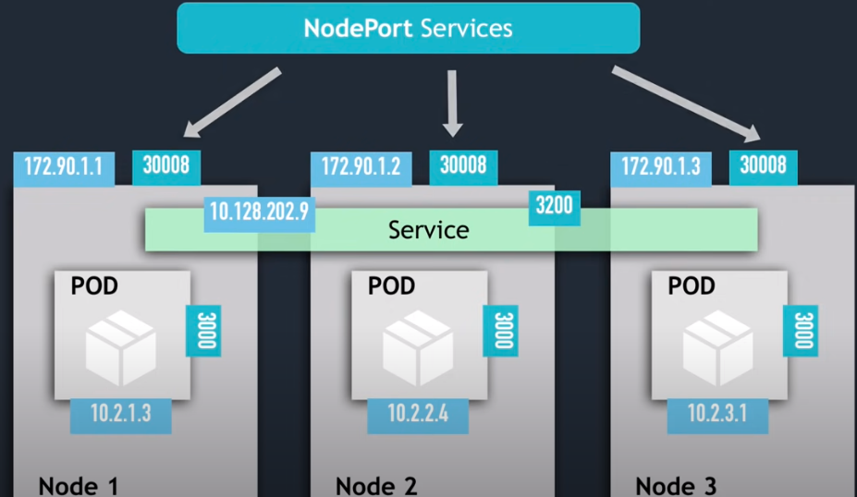

To rectify the security issues with NodePort services, we introduce a LoadBalancer service type. This is essentially the same as NodePort except we are using the LoadBalancer from our cloud provider to expose our nodes to the internet.
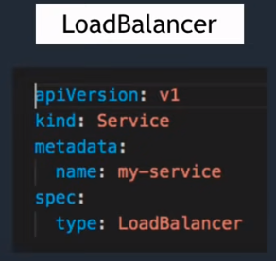

Each cloud provider has their own implementation of loadbalancing. Whenever we use a loadbalancing service, NodePort and ClusterIP are created automatically. Although our port 30010 is exposed, traffic from the internet will first hit the LoadBalancer, which can then direct the traffic to the destination node.
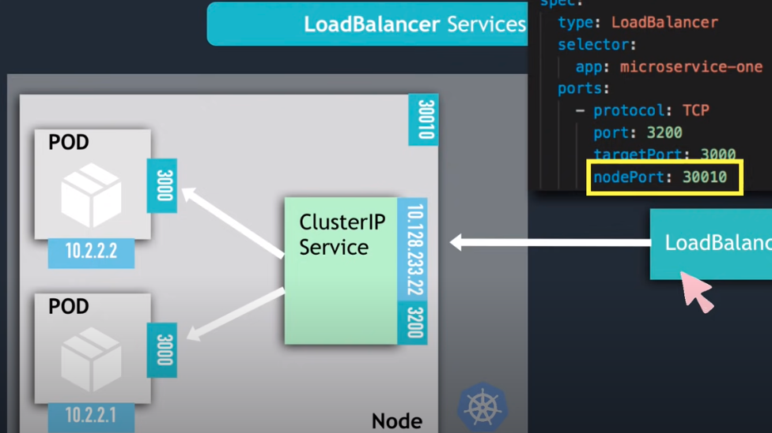

Hands On – Using the various service types

I. Create a ClusterIP service, apply it to the cluster, and verify.

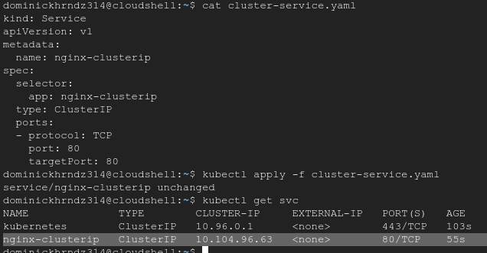

II. Create a NodePort service, apply it to the cluster, and verify.
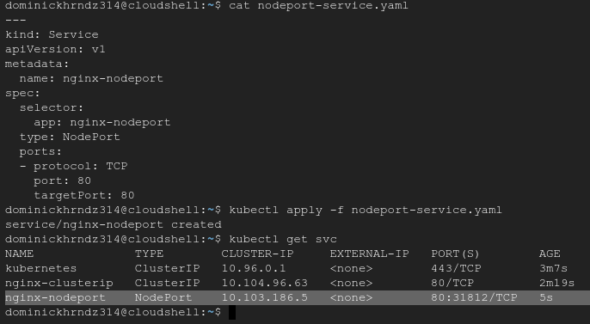
III. Create a LoadBalancer service, apply it to the cluster, and verify.

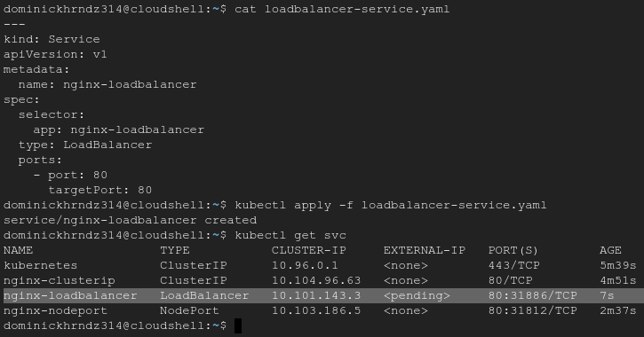
IV. Create 3 nginx pods for each service and verify all 9 deploy.
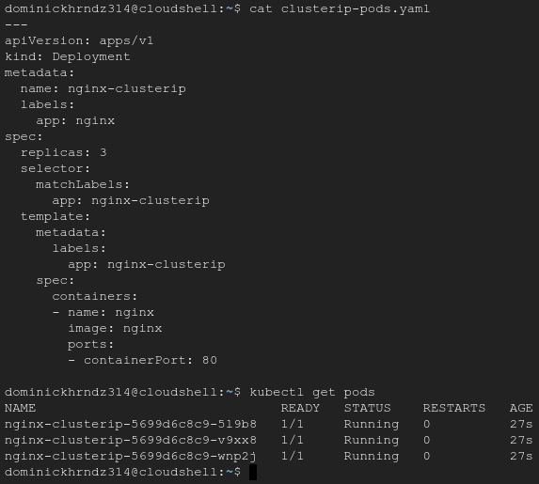

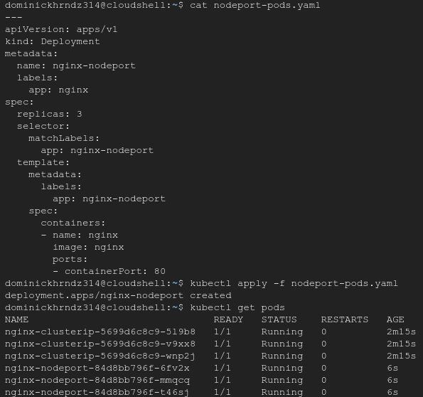

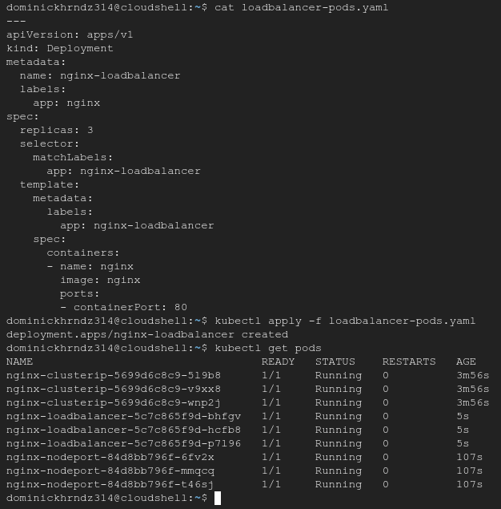

V. Verify all services and discuss why LoadBalancer is stuck in pending:

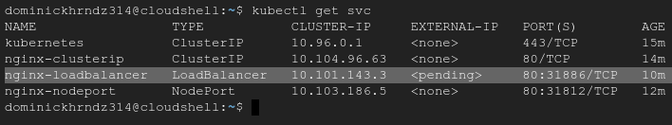
The LoadBalancer service type remains in pending status unless your cluster has integration with a cloud provider that provisions one for you through GCP or AWS.

If you can see all 9 of your pods and your 3 services list, you have completed this training. Please remember to delete all of you deployments using kubectl delete pods –-all and kubectl delete svc –all.

